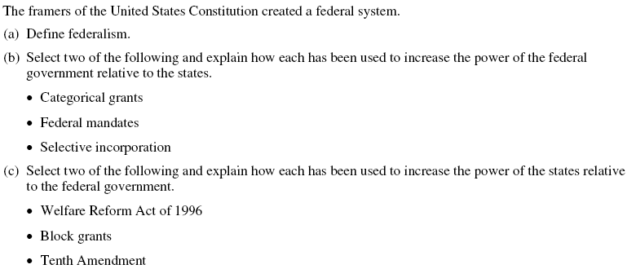
Five Steps to a 5 on your FRQs
Step One: Read the question
Step Two: Identify the Keywords: Federalism, Constitution, categorical grants, federal mandates, selective incorporation, Welfare Reform Act, Block grants, 10th amendment
Step Three: What does the question want you to do with the keywords (hint: underline verbs)?
Define—tell the meaning of
Explain—clearly state the why/how. Give reasons or causes for change

Step Four: Outline your response
The division of power between federal and state/local government
Federalism

- grant designed for a specific purpose
- Fed tells states how to spend $
  - Ex. Interstate highways, Head Start
Categorical Grant
Federal mandate
- Fed tells states what policies are carried out
  - Ex. Americans w/ Disabilities Act (ADA), click it or ticket

Welfare Reform Act
- States given $ to implement welfare
  - 1996-Clinton era policy
  - Cong. Republican strategy
- States choose best way to shift ppl. From welfare to work

- Fed $ for states
- Few restrictions
- States decide how to best spend $ to implement programs

Block Grants

- Reserves power to states and ppl.
- Devolution
  - Used to pass power from fed to state

10th Amendment

Step Five: Ready to write (restate each question prompt in the first line of your paragraphs)
A. The framers of the Constitution created a federal system in order to _______________________. Federalism means __________________________________. Since the creation of our nation, our federal and regional government have both shared power and wrestled for power.
B. Two ways in which the federal government has increased power over the states are ____________ and ____________. _____________ is best defined as_____________________________. An example of this would be__________________. Another feature of federalism is __________________. It is defined as ___________________________. An example of this is ____________________________.
C.Two ways in which the states increased their power as relative to the federal government are ___________and ___________. ________________ allowed states to _____________________ and ________________________________. Another way states increased their power was through the use of _______________________, which were used to _______________________. An example of a _______________ is _____________________. A third way in which the states increased their power relative to the federal government was through the Tenth Amendment. This amendment reserves powers not found in the Constitution and not prohibited by the Constitution to the states and the people (definition). Through the process of devolution, many states are pushing for greater power or sovereignty to be returned to the states (explanation of process).

